8th INTERNATIONAL CONGRESS and 13th NATIONAL of CLINICAL PSYCHOLOGY
ACCOMMODATION FORM

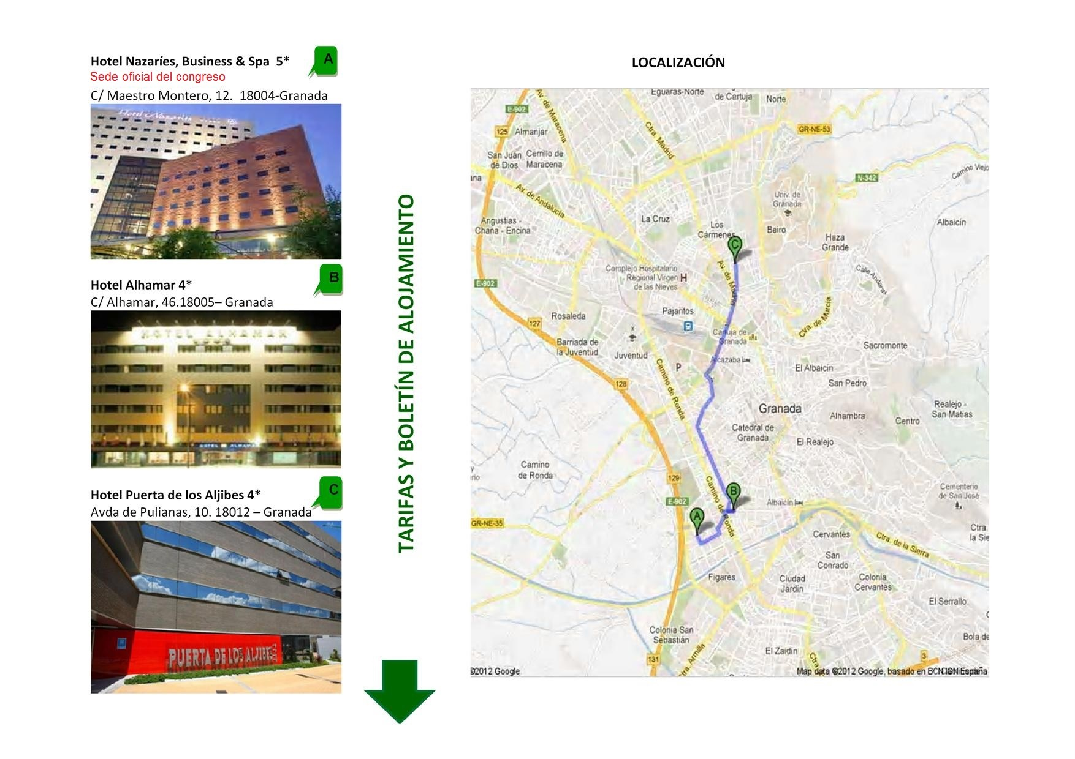
8th INTERNATIONAL CONGRESS and 13th NATIONAL of CLINICAL PSYCHOLOGY

Granada
November, 19-22, 2015

NAME |  |  |  |  |  |  |  | PASSPORT NUMBER
ADDRESS |  |  |  |  | CITY
COUNTRY |  |  |  |  | POSTAL CODE
TELEPHONE |  | FAX. |  | e-MAIL

COMPANY OR PRIVATE INFORMATION FOR BILLING
NAME
ADDRESS |  |  |  |  | CITY
COUNTRY |  |  |  |  | POSTAL CODE
TELEPHONE |  | FAX. |  | TELEPHONE

HOTELS. Prices per room and day – VAT included (Mark an X your choice)
HOTEL |  |  | LOCATION |  |  | SINGLE ROOM WITH  BUFFET BREAKFAST | TWIN ROOM WITH BUFFET BREAKFAST
 | Nazaríes, Business & Spa 5*  (Official Congress Venue) |  | C/ Maestro Montero, nº 12. 18004-Granada |  |  | 70 € | 90 €
 | Alhamar 4* |  | C/ Alhamar nº 46. 18005-Granada |  |  | 60 € | 60 €
 | Puerta de los Aljibes 4* |  | Avda de Pulianas nº 10. 18012– Granada |  |  | 60 € | 60 €
RESERVATION
NUMBER OF ROOMS |  | ROOM TYPE |  | ARRIVAL DATE |  | DEPARTURE DATE
PRICE PER ROOM |  |  | NUMBER OF NIGHTS |  | TOTAL TO BE PAID

FORM OF PAYMENT
- Bank Transfer in favor of the selected Hotel.(Indic “7th INTENATIONAL CONGRESS PSYCHOLOGY”)
BANK: BANCO POPULAR. IBAN: ES94 0075 0903 1706 0025 5573. CODE SWIFT –BIC: POPUESMM (Hotel MA Nazaríes 5*)
BANK: BMN CAJA GRANADA IBAN: ES45 0487 3296 71 2000097490. CODE SWIFT –BIC: GBMNESMMXXX (Hotel MA Alhamar 4*)
BANK: CAJA RURAL DE GRANADA IBAN: ES96 3023 0121 6859 39427802. CODE SWIFT –BIC: BCOEESMM023 (Hotel MA Puerta de los Aljibes 4*)
( Please send a copy of the transfer invoice by fax or e-mail with this form)
❑ CREDIT CARD I authorize the Hoteles MA to charge the amount of ___________ € on my credit card:




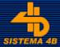
❑       
HOLDER______________________________________________
I AUTHORIZE Hoteles MA to charge my credit card for the total
amount of______________ € (please sign the rectangle)

CREDIT CARD NUMBER__________________________________
EXPIRY DATE ______________________ CVV _________
WE REQUEST YOU FILL IN THIS FORM AND SEND BY FAX OR E-MAIL TO THE SELECTED HOTEL:

Nazaríes, Business & Spa 5* | Alhamar 4* | Puerta de los Aljibes 4*
Telephone 958187600  Fax 958187601  E-Mail: reservas.nazaries@hoteles-ma.es  “Los datos personales incluidos en este documento son de carácter confidencial. De acuerdo con la Ley Orgánica 15/1999, de 13 de Diciembre, el titular de estos datos podrá ejercer su derecho de acceso, rectificación y cancelación solicitándolo por escrito a Hoteles MA a la Dirección del Hotel Seleccionado. | Telephone 958290303  Fax 958805508  E-Mail: alhamar@hoteles-ma.es | Telephone 958163000  Fax 958163001  E-Mail: puertadelosaljibes@hoteles-ma.es

